Smart Interaction System rendering Email access and voice command using gestures
Prof.Pooja Bhagat,Vrushali Deshpande, Sanika Haval, Aishwarya Daundkar, Rohankumar Patel
pooja.bhagat@dypiemr.ac.in
vrushu.bru@gmail.com
sanikahaval@gmail.com
daundkarash22@gmail.com
rohan.padmani@gmail.com

Department of Computer Engineering,
Dr. D.Y. Patil Institute of Engineering, Management and Research, Akurdi
Savitribai Phule Pune University, Pune, India

ABSTRACT

Dumb-blind communication can be a tricky topic to tackle. Assistive technology leading to full participation of specially abled people in a technological society could turn this huge communication setback to productive comeback. This proposed system works in the same direction. Gesture primarily based system is meant to produce the communication between dumb, deaf and blind people and their communication with the healthy person. Gesture used in this project is by using the data glove and it is based on the microcontroller. Data glove with integral sensor is employed to observe the movements of the hands and converts it into as voice output and generates email with predefined pictures and subject to the concern person.

Keywords— Gestures, Accelerometer, Raspberry Pi 3, Python and Firebase.

- Introduction
Communication with visually impaired people is still a difficult scenario to deal with. But with technology supporting tons of opportunities, proposed plan could lower the obstruction. It depends on the need of building up an electronic gadget that can make an recognition of gesture based communication into speech so as to make the communication between the mute groups with overall population conceivable.
- Literature Review
The analysis and some research has given suggestions clearly co-related to the innovations about the controlling of the signals in concern about the present population. Despite the information so as to there are individual observatory points as well as many focus to specify from the investigation, however this stereotype consider have additional keenness used for the accompanying classifications, because these are very important regions of movement based User Interface. It has been around thirty years of research and analysts have been working on motion based framework. The vast majority of the explores depend available motions. Coordinate control by means of hand stance is fast enough, however restricted in the range of Choices.
This survey tends to give an introduced insignificant exertion course of action which does in like manner in early-stage conditions without greatly multifarious nature. The same here is recognized through an assortment of sensors whose data is arranged and mapped to a particular attributes that can be controlled in the physical world. The paper looks at the structure prototyped to access the mouse of a PC through movements and tilt of the wrist. The same is recognized employing Accelerometer and a Flex sensor.

Sr. No. | Paper Title | Findings
1. | Hand gesture remembrance and voice conversion system for dumb people | Artificial speaking mouth for dumb people. Conversion of hand gestures into voice.
2. | Sign Language utilizing Automatic Hand Gesture Robot Based on Microcontroller System | Implementation of microcontroller for recognizing hand gestures and its conversion. Wireless connection between the database and sensor gloves.
3. | Gesture Recognition Technique: A Review | Interpreting human gestures via mathematical algorithms. Different ways of gesture recognition.

- Existing System
Flex sensors, tactile sensor, accelerometer is used to detect the hand gestures which are mounted on the hand gloves of the user with various resistance value of each sensor is detected and sent to microcontroller and matching the gesture to database based on the gesture shown. The gestures are detected using colors which ill mapped and compare the image stored in the database, if the image is matched the meaning of that particular gesture are displayed During the images segmentation stage the skin color detection and region segmentation is carried out and we now extract a 1D binary signal by tracking the circle constructed in the previous step. Ideally the unbroken “white” portions of this signal correspond to the fingers or the wrist. By tracking the circle, we keep the track of the transition i.e. either from white-to-black or black-to-white. We store the co-ordinates of the transition points and for visual convenience we plot the points on the circle. Limitations are connection between the flex sensor and the microcontroller is not effective. Hand gloves are mandatory for sensor based hand gestures recognition. The same text file should be converted to the audio file for voice output. Hand region tracking is tedious process to perform. Two way communications are executed only by matching the gestures in the database.

- Proposed System
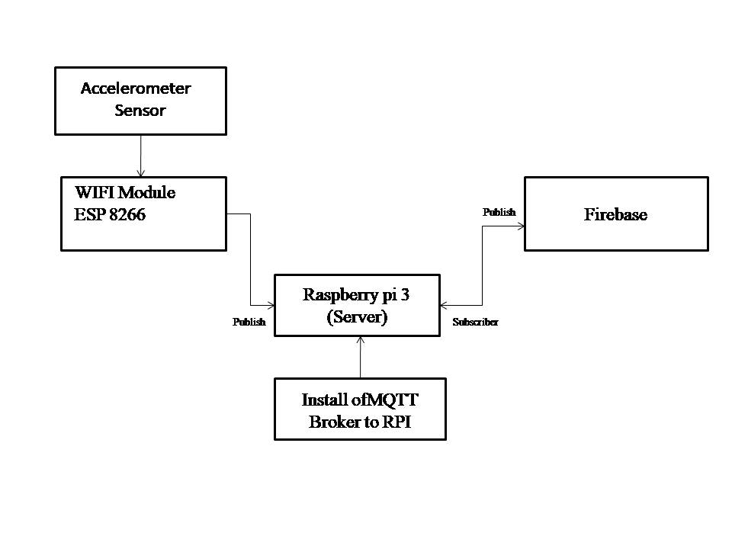
- Workflow and Architecture

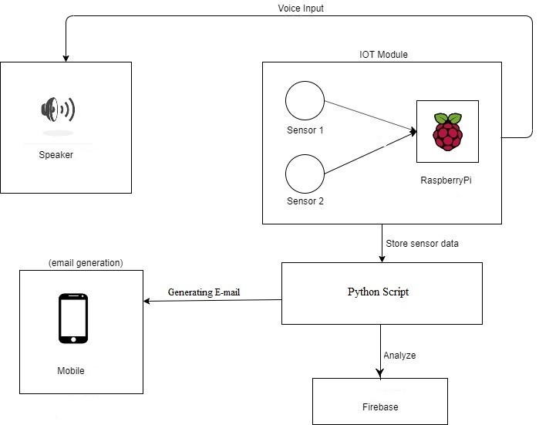

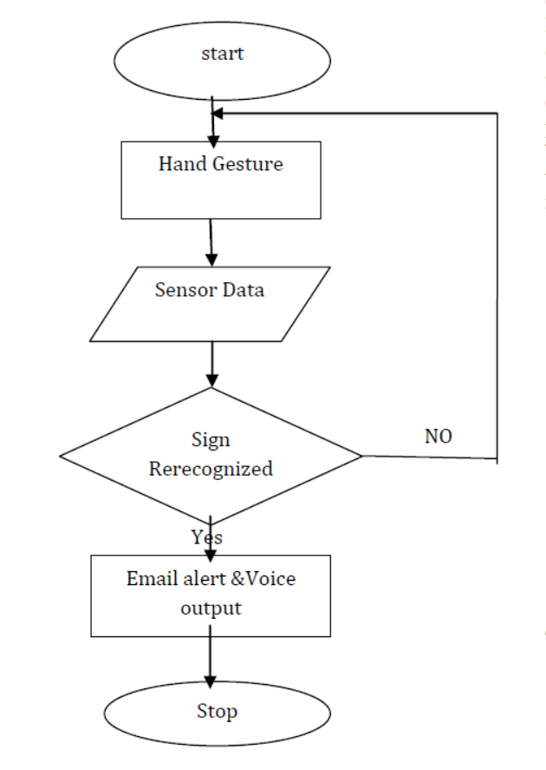

- Conclusion
The proposed prototype will help visually challenged and mousy people to communicate with the society. The system is supposed to convert sign language into voice output and text to predefined image as email to the concerned person. The system is efficient, reliable, easy to use as the circuitry is simple.

VII. Future Enhancements
Future enhancement is to do additionally investigate with a specific end goal to create improved form of the proposed framework. Framework would have the capacity to convey in both headings by precisely knowing the yield from a specific part. It will have the ability to make an interpretation of ordinary dialects to hand signals effectively. The picture handling some portion of the framework will likewise be altered to work with each conceivable condition. A test will be to perceive signs that include movement.

REFRENCES
1. Wolf, C. G. Can people use gesture commands? IBM Research Report, (RC 11867), April 7, 1986.
2. Sanna K., Juha K., Jani M. and Johan M (2006), Visualization of Hand Gestures for Pervasive Computing Environments, in the Proceedings of the working conference on advanced visual interfaces, ACM, Italy, p. 480-483.
3. K.Juha , Panu K.,M. Jani , Sanna K., Giuseppe S., Luca J. and Sergio D. M. Accelerometer-based gesture control for a specific design domain, Springer, Finland, 2005.
4. Jani M., Juha K., Panu K., and Sanna K. (2004). Enabling quick and effortless customization in accelerometer based gesture association, in the Proceedings of the third International conference on Mobile and omnipresent multimedia. ACM, Finland.
5.http://www.telegraph.co.uk/news/uknews/1563076/Elderly-addicted-to-Nintendo-Wii-atcare-home.html
6. Malik S. and Laszlo, J. (2004). Visual Touchpad: A Two-handed Gestural Input Device. In legal proceeding of ACM International Conference on Multimodal Interfaces.
7. P.Jia and Huosheng H. ,Head gesture recognition for handsfree control of an efficient wheelchair, Industrial Robot: An International Journal, Emerald.

